

Maharashtra Education Society’s

Institute of Management and Career Courses (IMCC), Pune
AUTONOMOUS

Academic Year 2025-26

F.Y. MCA Semester-I Course: ITP21 Mini Project

MEMORYLOG – Early Stage Dementia Detection

1. Introduction

Dementia is a neurological condition that affects memory, thinking, and daily functioning. Early detection plays a crucial role in slowing progression and improving quality of life. MEMORYLOG is a web-based application designed to detect early signs of dementia through cognitive games, assessments, progress tracking, alerts, and caregiver monitoring.

The system provides three roles:
- Patient (User) – performs cognitive tests and assessments
- Caregiver – monitors patient progress, alerts, and recommendations
- Admin – manages users

1.1 Project Scope
The scope of MEMORYLOG includes:
- User authentication and role-based access
- Cognitive games (Matching, Word Recall, Pattern)
- Automatic score storage and trend analysis
- Dementia stage assessment using questionnaires
- Doctor recommendations per stage
- Alerts and reminders for patients and caregivers
- Caregiver portal for monitoring linked patients
- Admin portal for user management
The project focuses on awareness and early detection, not medical diagnosis.

USER ROLES & RESPONSIBILITIES

1 Patient (User)
- Register and log in to the system
- Play cognitive games regularly
- Complete dementia assessment questionnaire
- View personal performance history

2 Caregiver
- Monitor linked patient’s progress
- View alerts for declining scores
- Access assessment results and recommendations
- Support patient based on system insights

3 Administrator
- Manage system users
- Monitor overall system activity
- Ensure data integrity and access control

2. Analysis and Design
2.1 Entity Relationship Diagram (ERD)

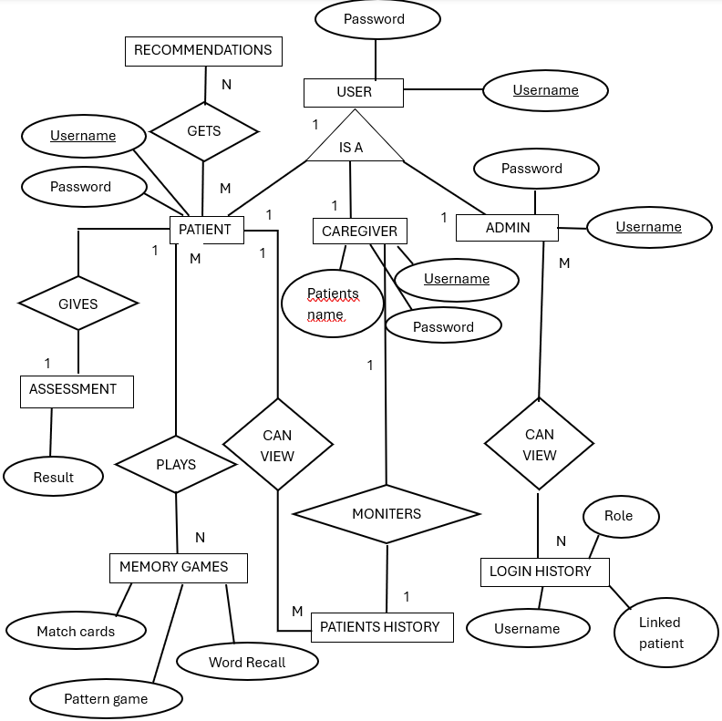

2.2 Use Case Diagrams
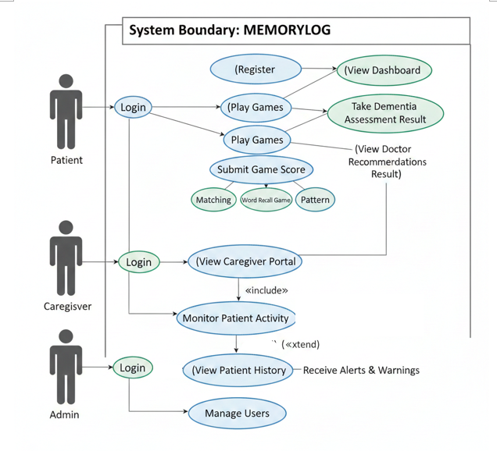

2.3 Table Structure / Data Dictionary
Users Table (JSON Structure)

Field Name | Data Type | Description
Username | String | Unique user ID
Password | String | User password
Role | String | patient / caregiver / admin
Linked_patient | String | Patient username (for caregiver)
Assessment stage | Object | Dementia stage and date

History Table

Field Name | Data Type | Description
Username | String | Patient username
Game | String | Game name
Score | Integer | Game score (0–100)
Date | String | Date and time

2.4 Sample Input and Output Screens

Landing Page:
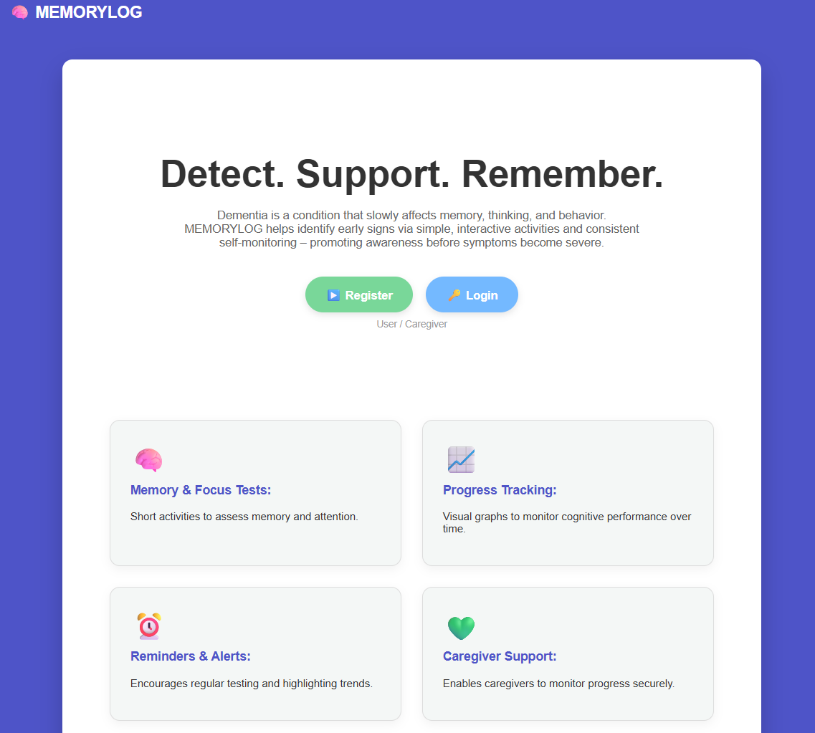
Login & Registration
- User selects role during registration
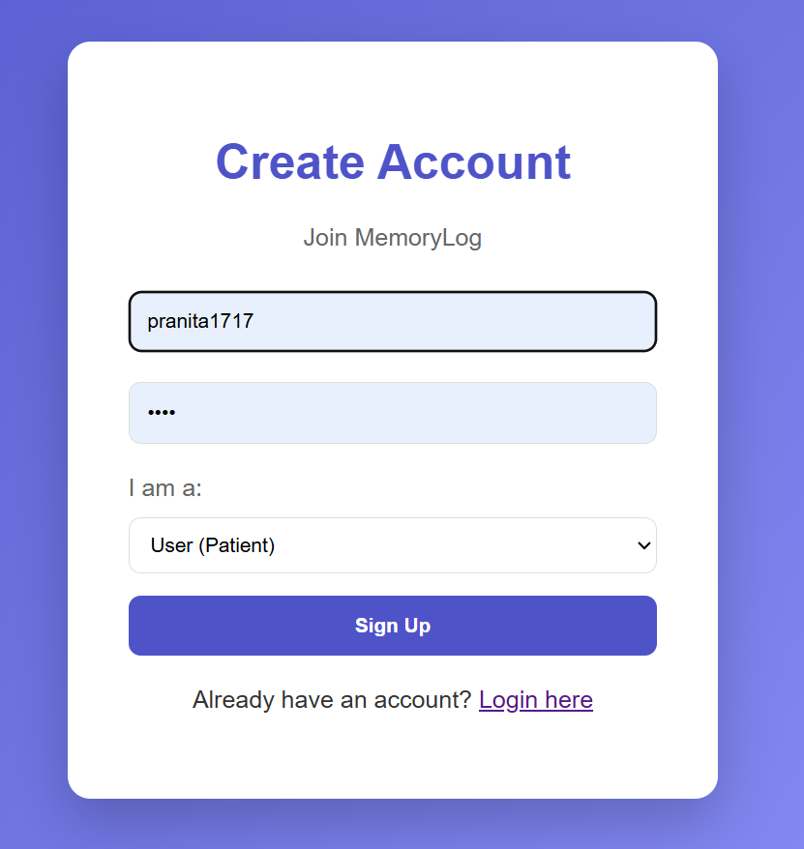

- Caregiver must link patient username
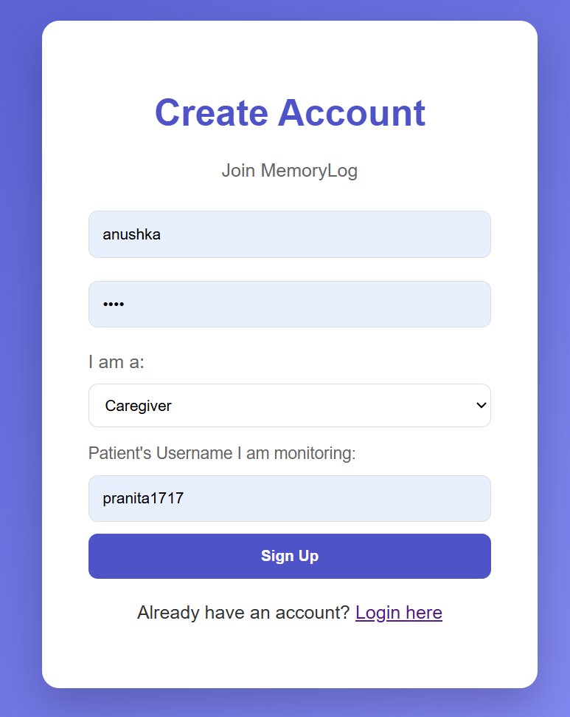
- Login redirects user based on role
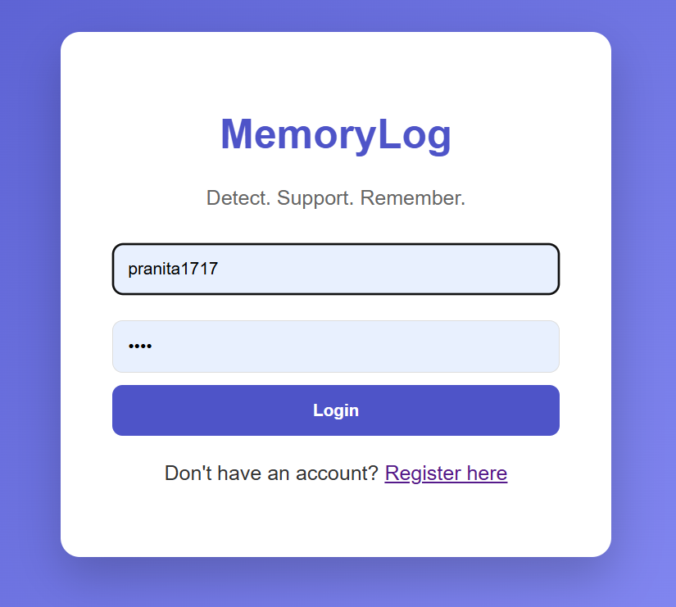

Patient Dashboard
- Play cognitive games
- Alerts for missed tests

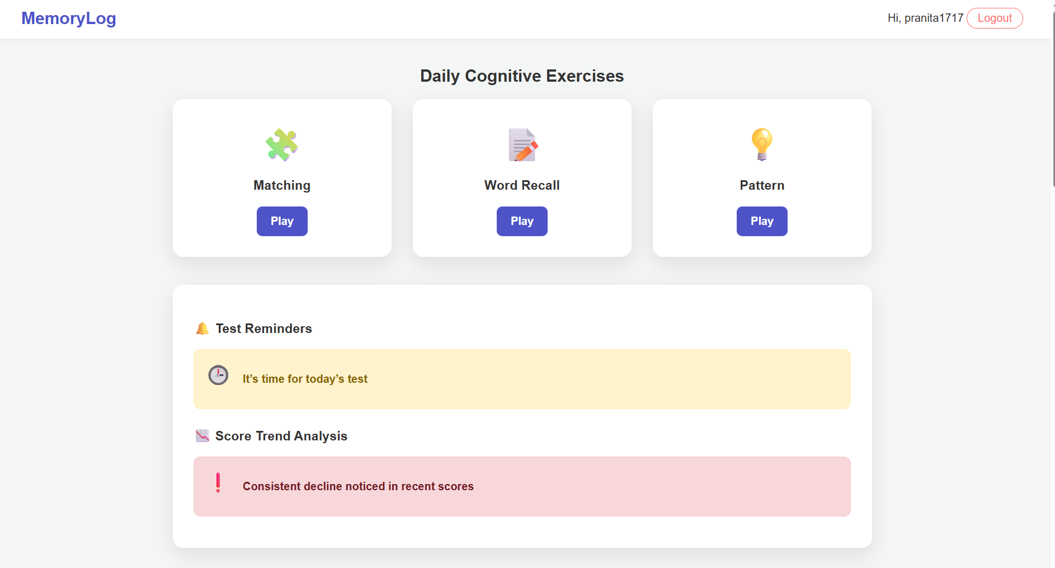
- Take dementia assessment
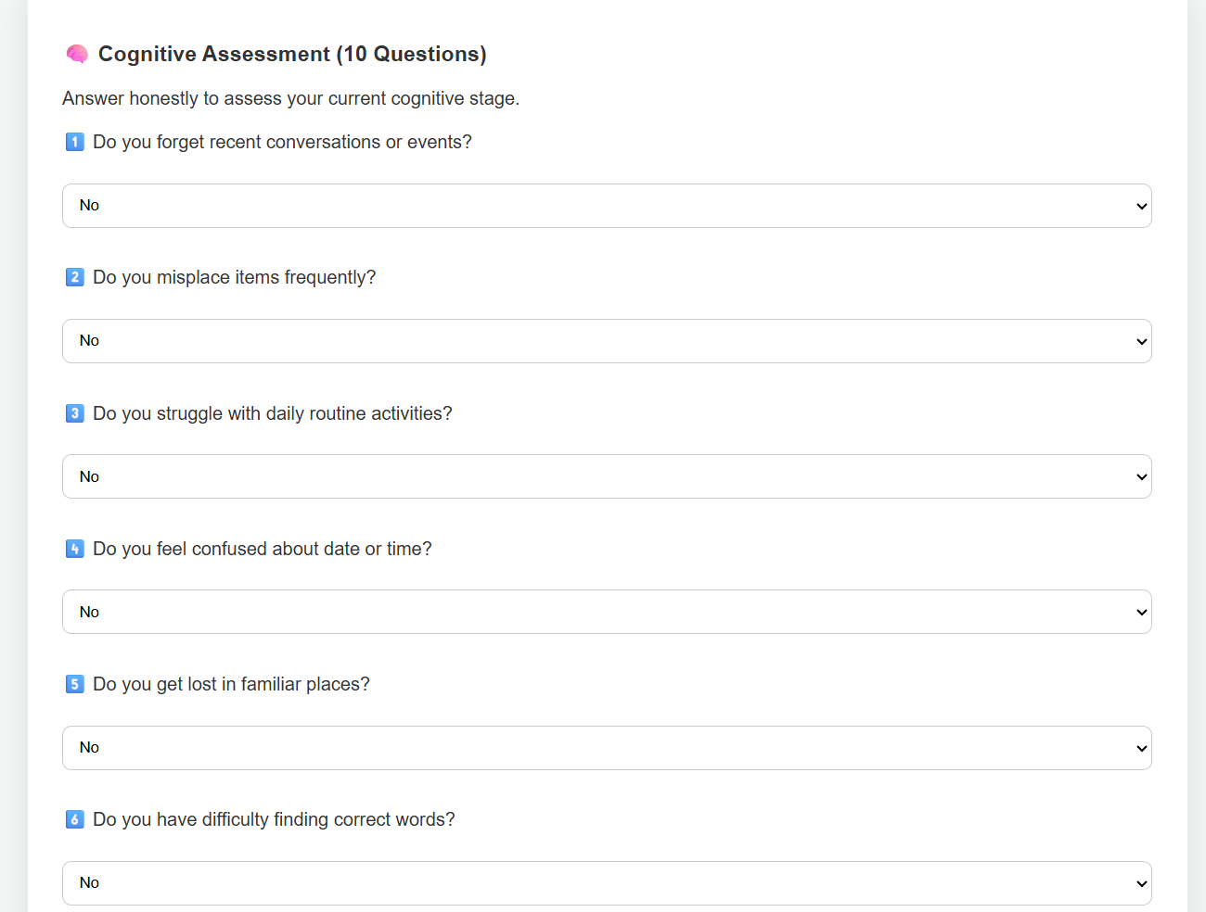

- View recent scores
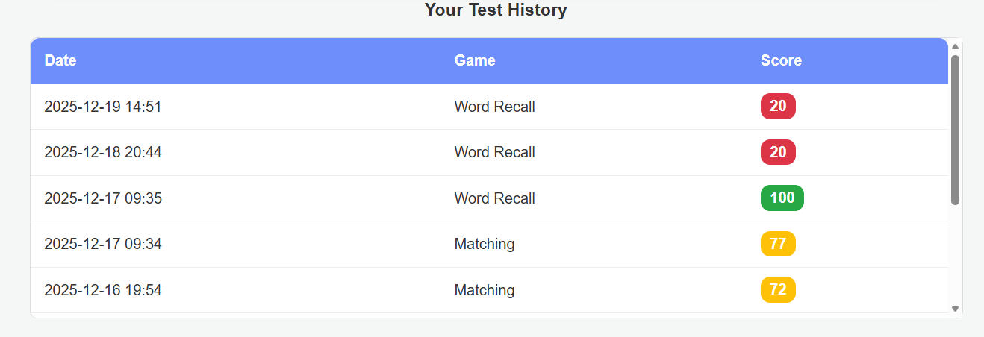
Games
- Matching Pairs – memory and attention
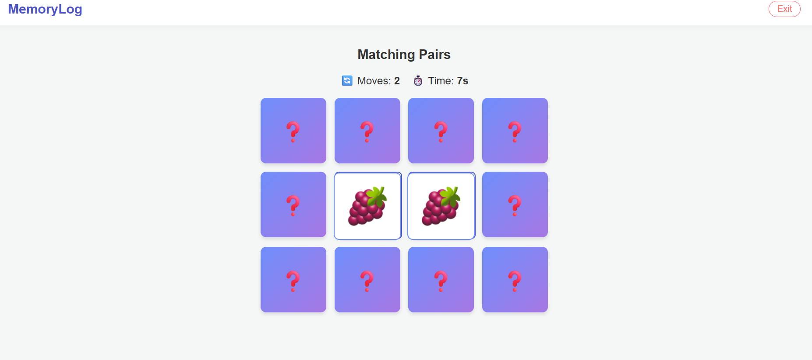
- Word Recall – short-term memory
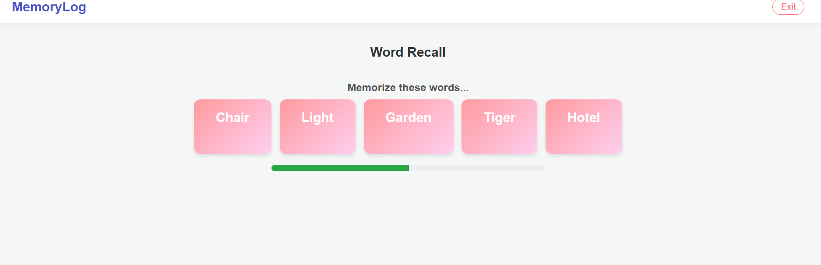
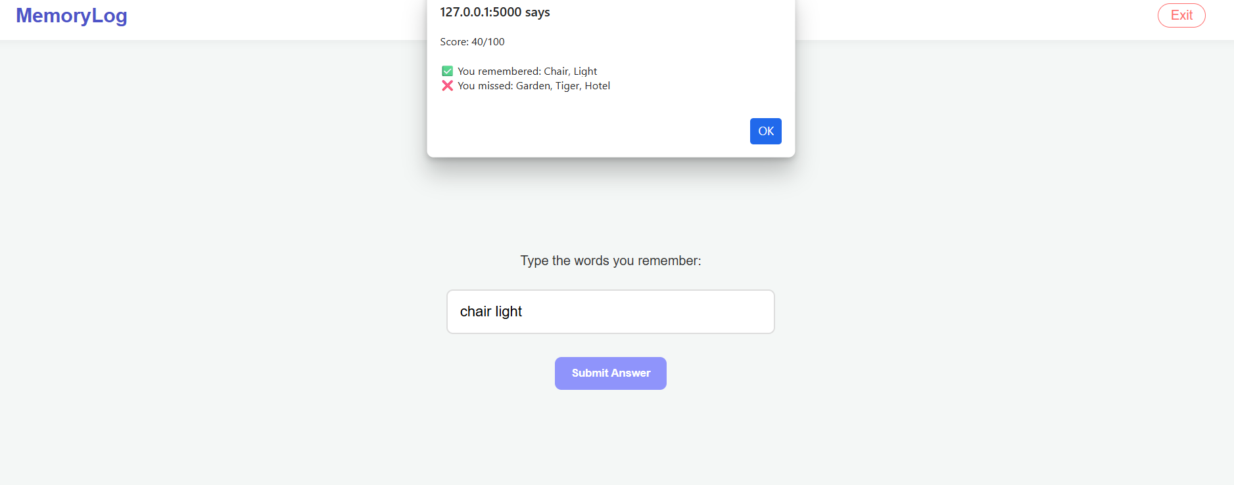
- Pattern Sequence – concentration and recall
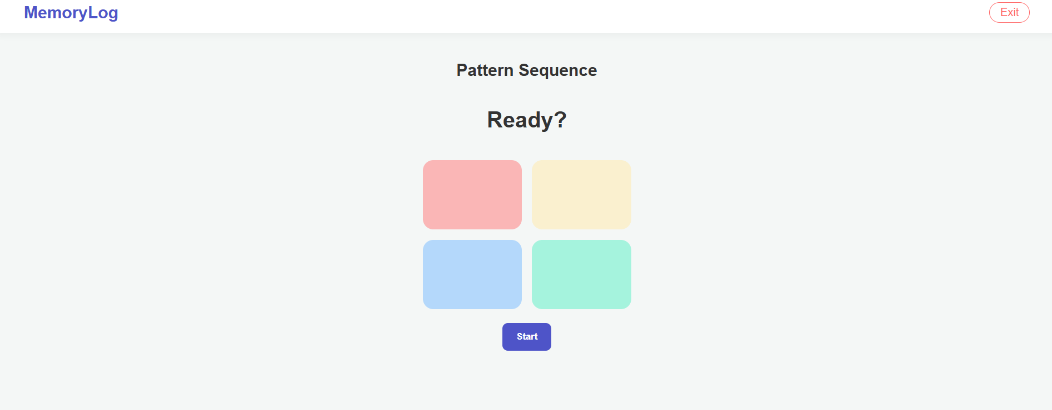

Dementia Assessment
- 10-question assessment
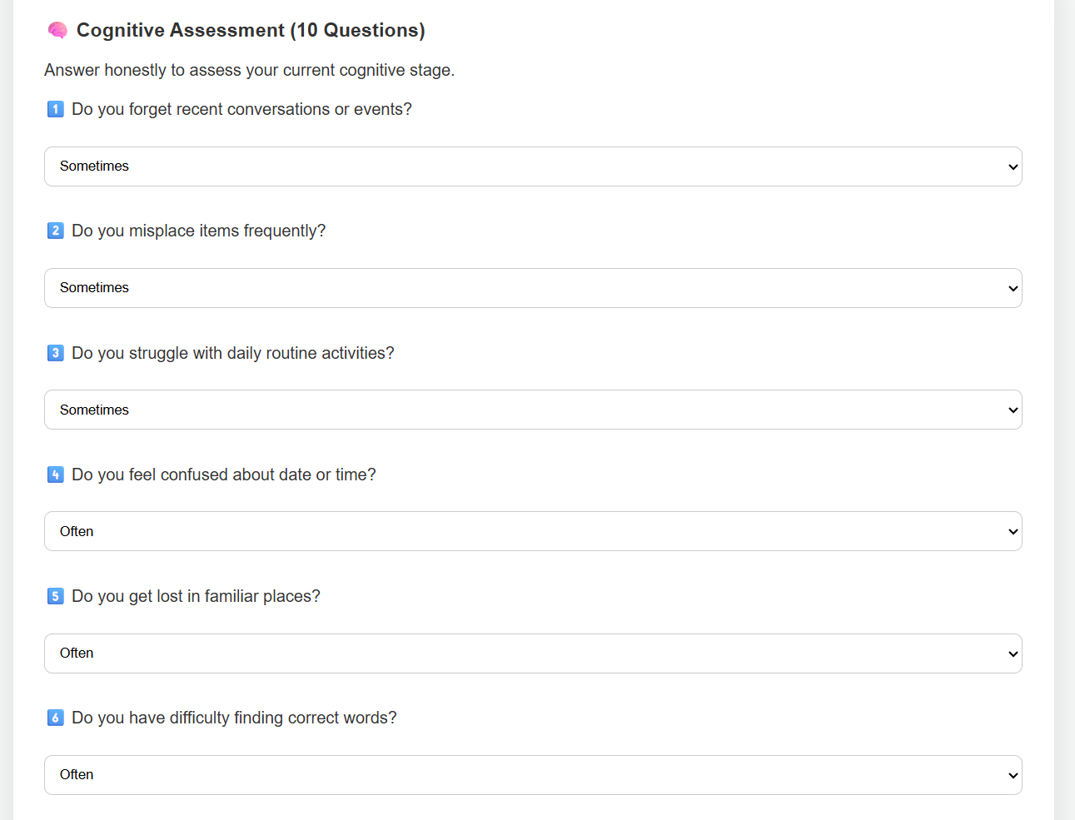
- Automatically detects stage
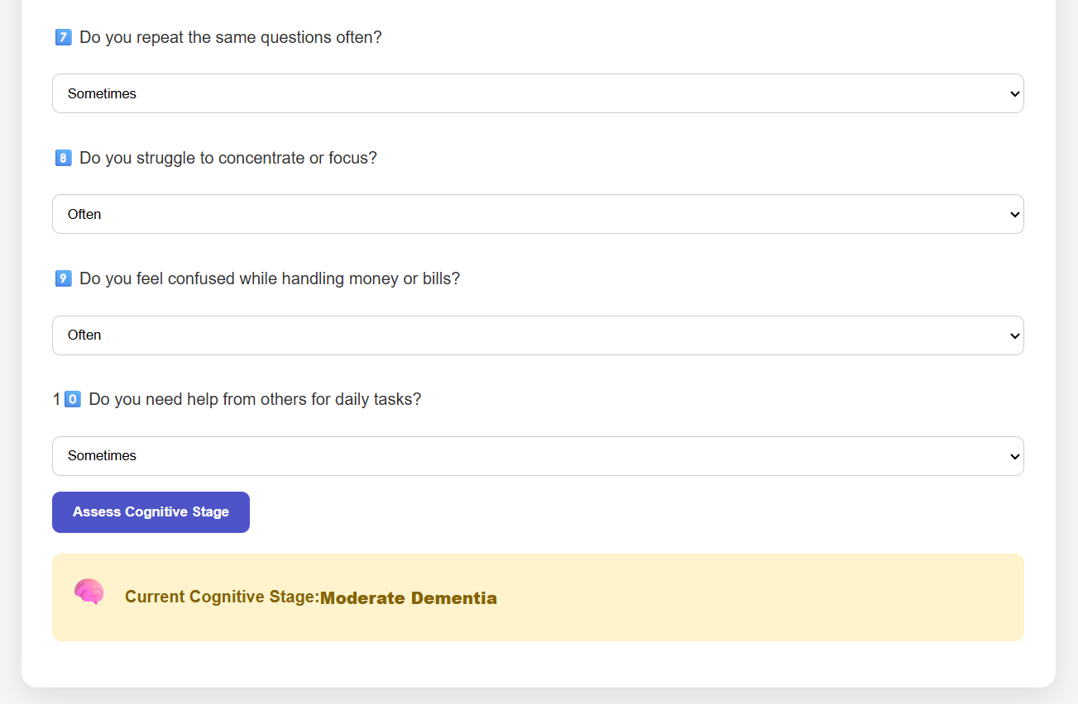

- Displays doctor recommendations
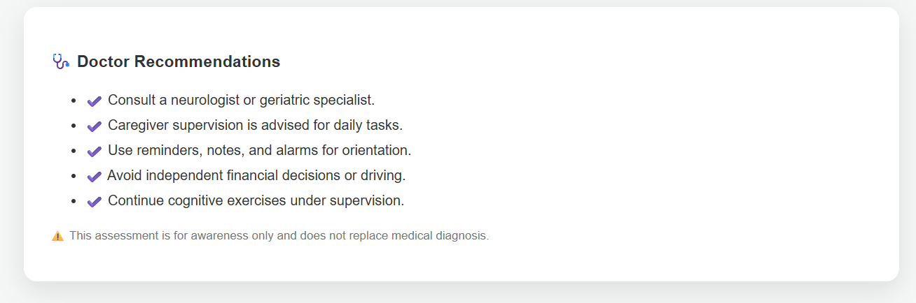
Caregiver Portal
- View assessment results
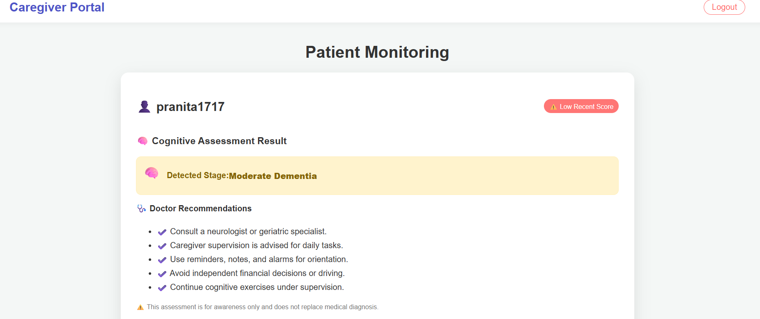
- Alerts for decline or missed tests
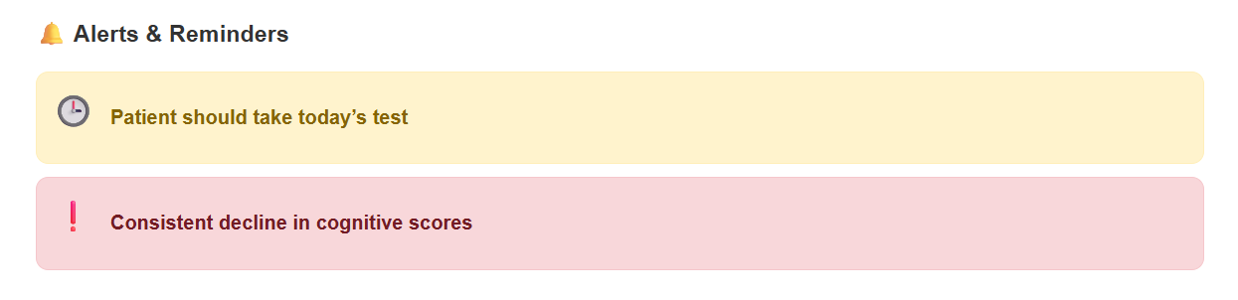

- View patient history and charts
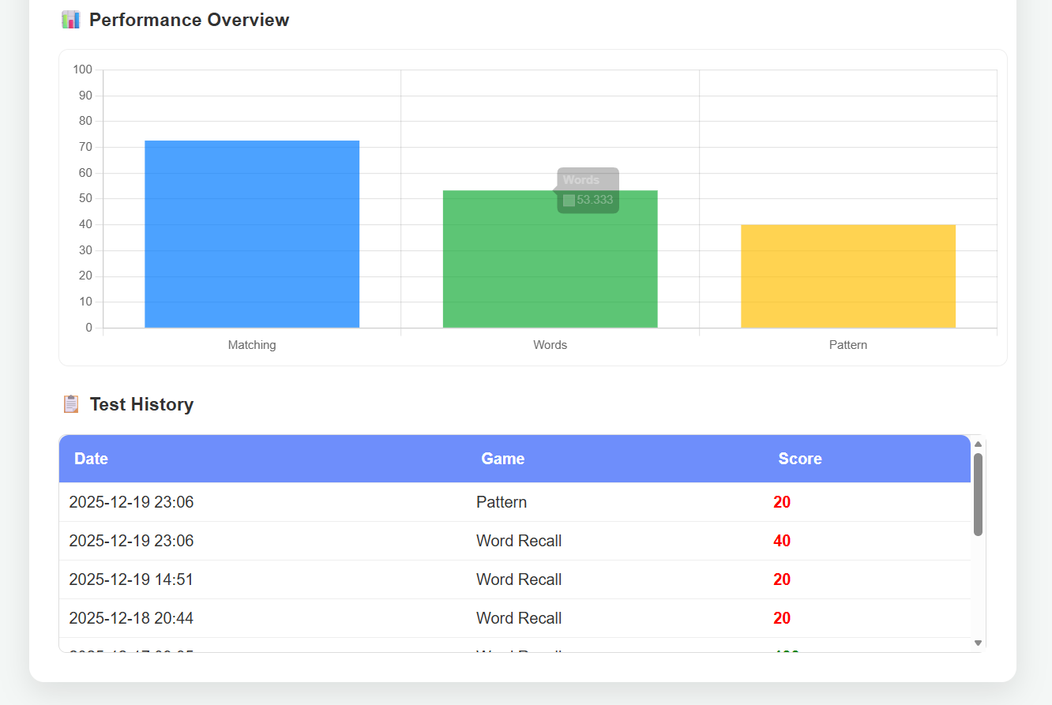
Admin Panel
- View all registered users
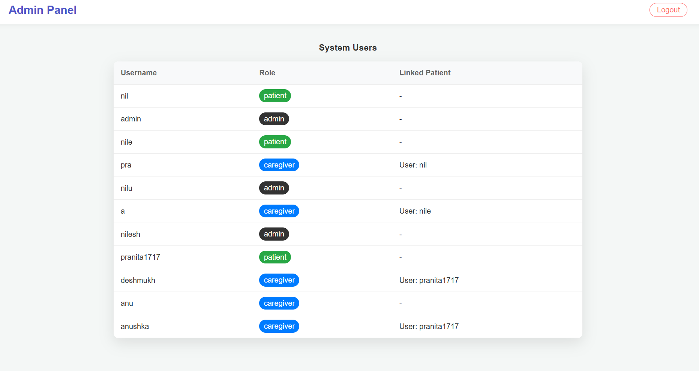

Conclusion
MEMORYLOG is a comprehensive web-based system that supports early dementia awareness through interactive assessments and caregiver involvement. The project demonstrates practical application of web technologies, database handling, and health-focused analytics.

